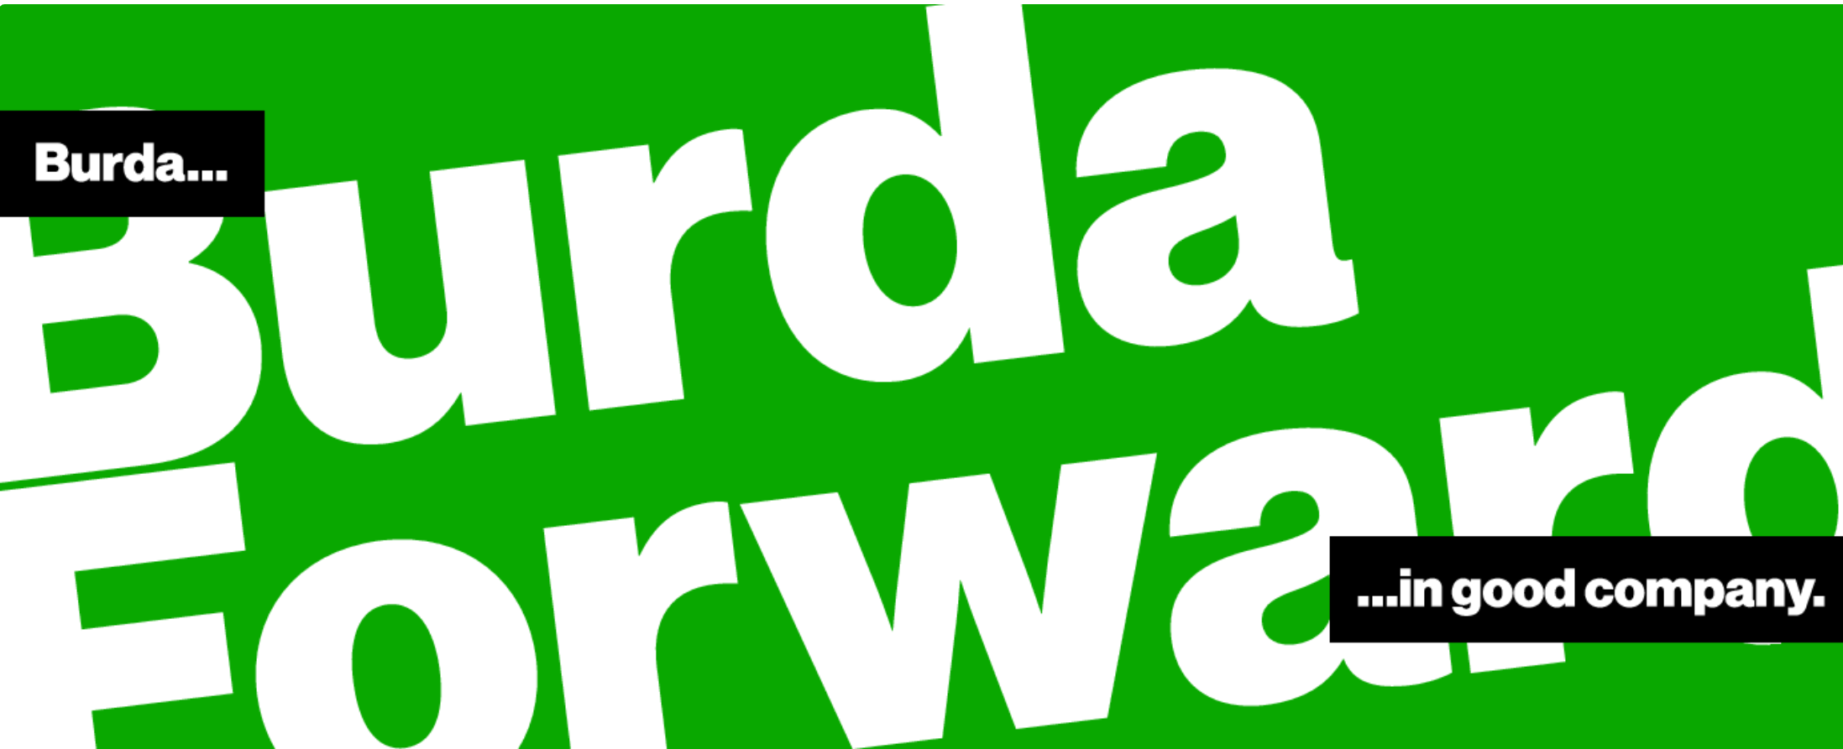

Senior Full-Stack JavaScript Software Engineer (m/f/x) at BurdaForward Italia

Are you a Clean Coder (m/f/x)? Do you like writing code but you are no code monkey? Do you know how Chuck Norris can Unit Test entire applications with a single assert? Then apply for your new potential job at our product and development site in Bari. Does this sound interesting to you? Then apply for your new potential job at our product and development site in Bari.
What you can expect from us...
- You´ll be working on a product and not projects
- This is a hands-on position: you´ll develop new features and services in close collaboration with
the product owner and the development team
- You´ll define and build the architecture and application stack in collaboration with the team
- You´ll contribute, communicate and cooperate closely across all BurdaForward teams, such as UX,
Operations and Data Science
- You´ll guide junior developers

What we would expect from you...
- You have at least 5+ years of working experience in designing and developing web applications and architectures
- You have knowledge of state-of-the-art backend technologies, such as serverless frameworks
(AWS Lambda), node.js and other JS frameworks
- You have solid knowledge of frontend technologies (HTML, CSS, JS) and corresponding frameworks
(e.g. Angular)
- You have experience with JavaScript ES6-ES7 and TypeScript in both frontend and backend
- You have experience with NoSQL Databases, RESTful API, JSON, XML, AMP, microservices,
web protocols, event driven architectures
- You have experience with native cloud development (AWS), CI/CD, auto scaling, infrastructure as code
- You have strong-problem solving skills and automated testing, performance and quality are important for you
- You can speak and write in English fluently and enjoy working in an international environment
- You have an Italian work or residence permit

What we can offer you...
- A permanent employment contract with a competitive RAL
- Smart Working - we believe in flexibility when it comes to choosing where you deliver top-notch work
- Mobile first! Every employee receives a smartphone and laptop for private and professional use.
You can choose between Mac or Windows device
- We Care! We provide lunch vouchers, fruits, water and coffee in all our offices
- A sunny office located in the center of Bari

Contact HR Bari :
Phone +39 339 773 22 03
Mailto : bari@burda-forward.de

