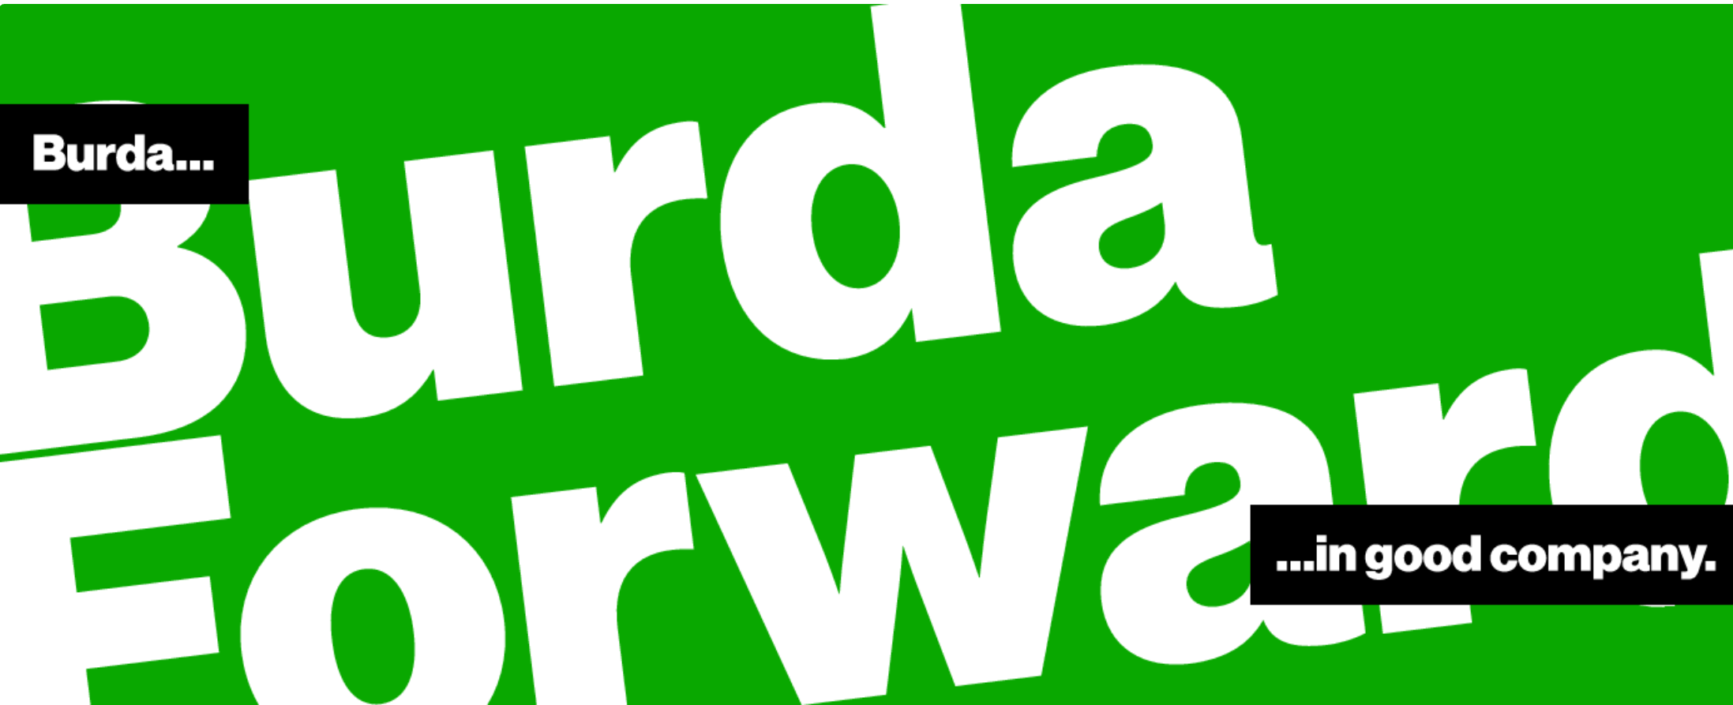

Senior Backend Developer (m/f/x) at BurdaForward Italia

Are you a Clean Coder (m/f/x)? Do you like writing code but you are no code monkey? Do you know how Chuck Norris can Unit Test entire applications with a single assert? Then apply for your new potential job at our product and development site in Bari. Does this sound interesting to you? Then apply for your new potential job at our product and development site in Bari.
What you can expect from us...
- You are responsible for the development of the backend for our Finanzen100 Apps and website – one of the most
popular finance portals in Germany
- Designing and engineering of software components in close collaboration with Product Management, UX,
Design,and of course your co-developers
- Working on a product and not on projects
- Our goal is to create products that not only work but are fun to use
- Permanent employment in a future proof environment

What we would expect from you...
- You have experience in the development of websites with agile development processes
- You have good knowledge of AWS, JavaEE, Kotlin, PostgreSQL, MySQL, Spring, nodeJS, GIT, Juni, Mockk, Docker,
Linux, Tomcat
- You have a good understanding of REST-APIs
- You have a high willingness to learn and are enthusiastic about new technologies and tools
- You can speak and write in English fluently and enjoy working in an international environment
- You have an Italian work or residence permit

What we can offer you...
- A permanent employment contract with a competitive RAL
- Smart Working - we believe in flexibility when it comes to choosing where you deliver top-notch work
- Mobile first! Every employee receives a smartphone and laptop for private and professional use.
You can choose between Mac or Windows device
- We Care! We provide lunch vouchers, fruits, water and coffee in all our offices
- A sunny office located in the center of Bari

Contact HR Bari :
Phone +39 339 773 22 03
Mailto : bari@burda-forward.de

