DISPLAYHUB GMBH

Embedded Sw and Network engineer
  - August 29, 2018

Background and Company Description
DisplayHub is a German based company, located in Karben, near Frankfurt am Main.
The company business is the development and the distribution of visualization solutions, mainly based on large size Liquid Crystal Displays. Part of the company business is the development of driving solutions and networking solutions for the displays, where the company provides its customers with project specific HW and SW.

Along with the plan of expanding its business towards highly integrated solutions, DisplayHub is planning to expand its organization, acquiring a junior engineer giving him/her the possibility to build an international experience and a strong competence in the fields of combined digital electronics and embedded software.

Project Scope
Develop the skills and competences of a system software engineer, with the target to hire him permanently as responsible person for design and production of DisplayHub integrated solutions and customers support.
Starting from his/her skills, acquired at the university, we want to offer the possibility to develop them further so that the candidate can become the leader of the embedded software development within the company.

High-Level Requirements

The candidate must have a University Degree in Computer Science (Laurea Triennale in Informatica) and the following skills/orientation:
- Ability to work in a multi-cultural environment
- Ability to use English (spoken and writer) as primary working language
- Willing to work in Germany (region of Frankfurt am Main)
- Availability to travel for short period of time within Europe, to support the customers in the design-in process
- Flexibility to work along with projects schedule and requirements
- Good skills of ANSI-C programming language
- Programming in Java language is a plus
- Knowledge of the most common network protocols and programming languages
- Basic skills of Digital Electronics (circuits macro-blocks)
- Basic skills on 8bit/32bit/64bit Microcontrollers and CPUs

Business Processes or Systems

The junior engineer is requested to support DisplayHub R&D Manager by developing the following tasks:

- Co-develop the HW solution specification (high level concept design)
- Co-develop the FW platform for DisplayHub new display controller boards
- Co-develop the HW+FW platform for DisplayHub networking solutions (i.e. SNMP)
- Co-develop the HW+FW platform for DisplayHub IoT solutions (i.e. Samsung Artic)
- Develop the product documentation package and application notes
- Support the customers in the design-in process and in the after-sales inquiries

The activity will also include the co-ordination with the other company functions and external partners for the acquisition of all the needed competences and support.

- Microsoft C++ Debugger and Compiler
- Paradigm Ansi C Compiler
- Java Compiler

Examples of products/application areas
Here below we would like to present some project cases, for reference:

- DisplayHub Display Controllers

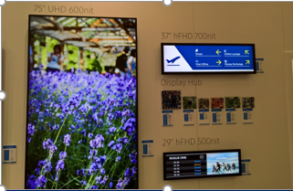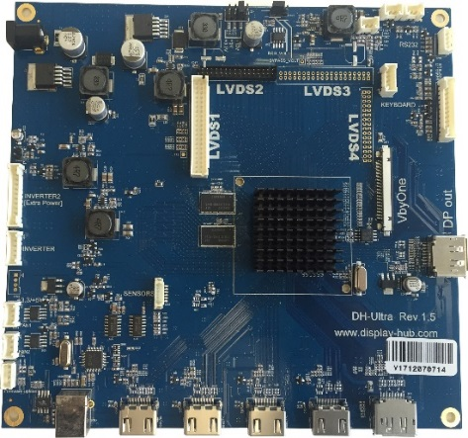

- Samsung Aritk IoT Solution

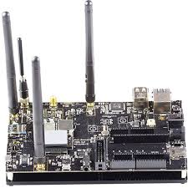

Job location:
Karben, Germany (Frankfurt am Main)

Timeline
DisplayHub is looking to start the collaboration within the end of 2018, according to the selected candidate availability to join the team.

Contacts:
Ruggero De Luca
Managing Director
DisplayHub GmbH
Dieselstrasse 22
D-61184 Karben
Germany
Email: rdeluca@display-hub.com
Telephone: +49 (0)6039 9387085
Mobile: +49 (0)173 1826656
Web: www.display-hub.com

