C.A.P. – UNIVERSITY CENTRE FOR LIFE-LONG LEARNING

MISSION

The service of CAP is addressed to all European and non-European citizens and its mission is to empower the "cultural values" as important and strategic resources for humanity.

VISION

CAP offers a free service of vocational guidance with a support to the recognition of qualifications, and/or training credits already acquired by non-EU citizens in their country of origin, as well as a service for the validation of the professional skills acquired in past work experiences.

VALUES

Actually CAP is the only University centre for life long-learning in Italy that permits a recognition of high school and university degrees and a validation of the soft skills of refugees.
Its aims are to promote processes of life-long learning and to certificate and give credit to the competences that everyone can obtain in formal, informal and non-formal contexts. It offers financial support for refugee students and operates through networking with institutional and University representatives involved.

PRIORITY RESEARCH
ERC sectors (European Research Council) are groups of different disciplines focusing on a particular scientific branch according to the European order.
Sectors have been established by the European Council of Research.
- SH2_1 SH2_8: Institutions, values and beliefs and behaviour
Sociology, social anthropology, political science, law, communication, social studies of science and technology
- SH3_5 Environment and society
Environmental studies, demography, social geography, urban and regional studies
- SH4_11 The Human Mind and its complexity
Cognition, psychology, linguistics, philosophy and education

Cap - University centre for life-long learning is composed by interdisciplinary experiences of sociology, psychology, job–psychology, and didactics as well as the judicial and social-historical aspects. All this is granted by researchers and academics joining the Scientific Board.

ACTIVITIES

• Judicial inquiries and legal advices to request equipollent documents of previous jobs and studies career.
• To bring out the professional and not-professional experiences and recover all professional skills that have been acquired "on the job"; after this it will be possible to start the procedures to recognize the professional skills as decided by the "professional inventory" edited by the Apulia Region (www.sistemapuglia.it ); finally it can be possible to ask for a "translation" of all skills in professional ones and/or credits useful for a new university career and/or new jobs.
• Transparency and certification of soft skills.

Cap is the only centre that granted the services of mentoring and validation of competences according to the National and Regional system of Validation and Certification of competences.
INTERNATIONAL NETWORKS

CAP is part of a wide partnership developed to have a better efficacy and to obtain better results.
The partners are:
CIMEA: Centre for mobility and academic equivalences.
ENIC NARIC: European Network of Information Centre in the European Region
RUIAP: It is a net of 30 Italian Universities focusing on life-long learning joined to EUCEN.
REFUGEES WELCOME MAP : It has been established because of a collaboration between the Association of European Universities (EUA), that granted a web of 850 universities in 47 countries.

STUDENTS’ ACHIVEMENT
Talents’ Generation Cap is a database of human resources and cultural heritage including the different users’ professional competences according to the age.
Cap’s Migrant Talent can be visited on-line – http://www.uniba.it/centri/cap

KEY INITIATIVES
Transfer of knowledge and E-talents placement: Cap promotes, throughout the ethnographic research and the collection of story- lifes and different competences, the spread of knowledge and human resources of immigrants and refugees and so on.
After a first meeting the users are entitled to test the possibility to show their competences and make titles of studies, soft skills and also competences resources that can be spent for job searching.

SPEAK MY LANGUAGE
- StraUniba_Students Resources Advantage for a better relationship with foreign students
It is part of the program Stra-Uniba (Students Resources Advantage) and Speak my language is an initiative that permit a volunteer language exchange between migrants and italian students who want to improve the knowledge of foreign languages.
Speak my language’s aim is to promote an exchange of informal linguistic competences mixing multiculturalism and friendship. The participation is free. The project is organized voluntarily by Cap’s staff according to the aim of the program “Essere Comunità” founded by the Department of Welfare – Municipality of Bari

SERVICE OF MENTORING AND TUTORING FOR EDUCATIONAL SUCCESS
Output of this service: 13 scholarships assigned from Crui and from the Ministry of the Interior in co-operation with ADISU: the aim is to guarantee the right to study for refugees and migrants holders of political asylum. All these persons are users of Cap and they have applied for the three-year degree programs, master and Ph.D. at the University in Bari for the academic year 2016-2017.

HISTORICAL EVOLUTION

Cap is the spin-off of the project “Work for you” - FEI 2013 Az. 3 “Work for you” has been a detailed work done by a multiethnic and multidisciplinary team composed of about 90 professionals (mediators, expert guidance, foreign tutors). The project has met more than 400 citizens of developed countries, the users have been granted over 9000 hours of individual and group career counseling in Bari, Lecce and Foggia.
The importance of this project was the testing of 102 soft skill certification paths (eg. Communication, negotiation, stress management, decision making etc.) all skills acquired in formal and informal settings by users in their home countries, for example through work experience but also voluntary experiences. To each users was granted a certificate signed by the University which can be used strategically in seeking employment and in job interviews.
Since February 2016 CAP addresses to people coming from countries in situation of conflicts (Syria, Pakistan, Afghanistan, Yemen, Eritrea, Africa), already holders of political asylum, subsidiary and community protection, adopting a simplified procedure for the recognition of equivalence for degrees and for enrollment at University in Bari. CAP gives opportunities even in absence of evidences and documentation and providing a consistent waiver of fees for the enrollment at university.

LIBRARY
Cap has at its disposal the system of library service available to the University if Bari.
The entire system of library is granted by SOCINDEX database with full-text fixed on the online platform EBSCO.
The Italian reviews in paper format are:
MONDI MIGRANTI:
- sociologia e ricerca sociale
- sociologia e politiche sociali
- etnografia e ricerca qualitativa

<http://opac.uniba.it/easyweb/w8018/index.php?EW_T=M1&EW_FL=w8018/ew_limiti.
<http://opac.uniba.it/easyweb/w8018/index.php?scelta=scheda_bib&biblio=BA074
<http://opac.uniba.it/easyweb/w8018/index.php?EW_T=M1&EW_FL=w8018/ew_limiti.
<http://opac.uniba.it/easyweb/w8018/index.php?scelta=scheda_bib&biblio=BA074
<http://opac.uniba.it/easyweb/w8018/index.php?EW_T=M1&EW_FL=w8018/ew_limiti.
<http://opac.uniba.it/easyweb/w8018/index.php?scelta=scheda_bib&biblio=BA074
<http://opac.uniba.it/easyweb/w8018/index.php?EW_T=M1&EW_FL=w8018/ew_limiti.
<http://opac.uniba.it/easyweb/w8018/index.php?scelta=scheda_bib&biblio=BA074
<http://opac.uniba.it/easyweb/w8018/index.php?EW_T=M1&EW_FL=w8018/ew_limiti.
<http://opac.uniba.it/easyweb/w8018/index.php?scelta=scheda_bib&biblio=BA074
<http://opac.uniba.it/easyweb/w8018/index.php?EW_T=M1&EW_FL=w8018/ew_limiti.
<http://opac.uniba.it/easyweb/w8018/index.php?scelta=scheda_bib&biblio=BA074
<http://opac.uniba.it/easyweb/w8018/index.php?EW_T=M1&EW_FL=w8018/ew_limiti.
<http://opac.uniba.it/easyweb/w8018/index.php?scelta=scheda_bib&biblio=BA074
<http://opac.uniba.it/easyweb/w8018/index.php?EW_T=M1&EW_FL=w8018/ew_limiti.
<http://opac.uniba.it/easyweb/w8018/index.php?scelta=scheda_bib&biblio=BA074
AA.Vv.(2010). La partecipazione degli immigrati all’associazionismo come veicolo di integrazione sociale. Rapporto di ricerca. A cura di Strategie srl e Istituto Psicoanalitico per le Ricerche Sociali. Tipolitografia CSR, Roma.
Acocella, I. (2008). Il focus group: teoria e tecnica. Milano: Franco Angeli.
Ashmore, R. D., Deaux, K. & McLaughlin-Volp, T. (2004). An organizing framework for collective identity: articulation and significance of multidimensionality. Psychological Bullettin, 130(1), 80-114.
Entzinger, H. & Biezeveld, R. (2003). Benchmarking in immigrant integration. Rotterdam: Erasmus University.
Freire, P. (1964). La educaciòn como practica de libertad. Mexico, D.F.: Siglo XXI
Waters, M.C. & Jiménez, T.R. (2005). Assessing immigrant assimilation: New empirical and theoretical challenges. Annual review of sociology, 105-125.
CODRES(2000). La rappresentazione diffusa. Le forme di partecipazione degli immigrati alla vita collettiva. www.cnel.it
Dipartimento per le pari opportunità, UNAR (2014), Dossier statistico immigrazione, Centro Studi e ricerche Idos, Roma.
Regione Puglia, Assessorato al Welfare, Puglia Sociale, nessuno escluso, Piano regionale Politiche sociali 2013-2015.
Fantozzi P., La Spina A. (2009), La distanza sociale. Distanti e disuguali nelle città del Sud, FrancoAngeli, Milano.
De Luigi N., Gobbi L. (2010), Giovani e genere, Carocci, Roma
Colozzi I., Giovannini G. (2007), Young people in Europe, FrancoAngeli, Milano.
Bevilacqua E. (2009), Disuguaglianze e teoria sociale, Bonanno editore, Roma.
Bambi E., Morciano D. (2008), Voci dal sommerso. Storie di lavoro non regolare, Pensa Multimedia, Lecce.

LABs
Laboratory of welcome and mentoring (room 123)
Laboratory of ethnographic Research “Focus Group discussion” and re-construction of refugees’ story – life. (room 506)
Laboratory of business creation (BaLab – Multifuncional Center in University of Bari)
Laboratory of refugees‘ talents and certification of soft-skills (room 121)

EQUIPMENT

Cap set up resources and specific instruments for ethnographic research as audio and video recorder, monitors, pc, desks, chairs, projectors, microphones, boards, materials for promotion and communication (roll-up, posters and brochures) computer programs and statistics ones useful rof social and ethnographic researches (spss, tlab).

PLATFORM
Cap focuses on Long Life Learning and the achievement of all users located on this territory; for this reason it has an on-line platform to guarantee e learning and blended modalities of training.
Furthermore Cap’s research labs, are using methods and techniques of psychological-sociological and pedagogical research to collect and analyze datas and autobiographical information of users underlining the ethnographic and story life’s aspects of users.
Datas are available in E-Talent database.

PLACE
https://goo.gl/maps/F7yqYeEw1cF2

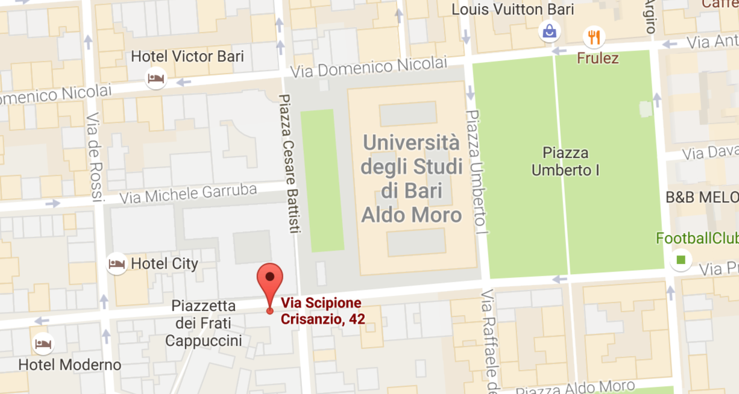

CONTACT
President of Cap: Fausta Scardigno
Address: via Crisanzio n. 42 – Palazzo Chiaia-Napolitano – University of Bari
First Floor –
Room:n.123
Tel.Number +390805714726
Internal Tel. Number 4726
E-mail: sportello.cap@uniba.it
Website: http://www.uniba.it/centri/cap

